Link:

* Notes

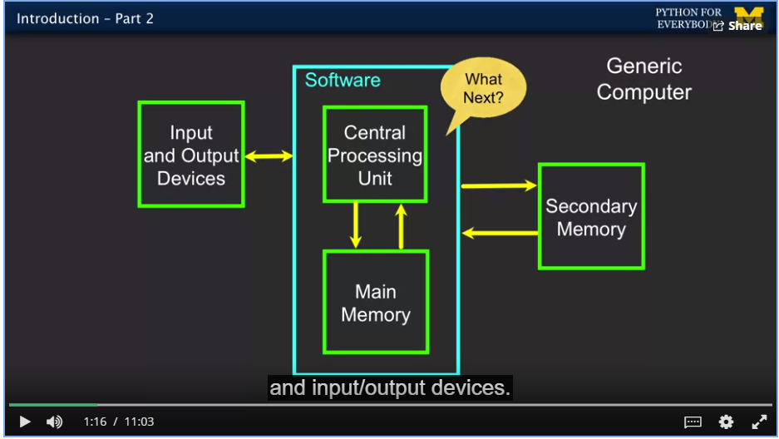

We recommend that you use the Atom text editor for this course. We prefer it because it works the same on Windows, Macintosh, and Linux. All of the course demonstration videos use Atom. You can download and install it from:

**https://atom.io/**

If you do use Atom, be aware that user input is not supported when scripts are run from the editor rather than the command line.

If you already have a text editor like **TextWrangler**/**BBEdit** on the Macintosh and NotePad++ on Windows, they can be used for this course. Of course, you can use any text editor or IDE that you like. If you install Python using the **Anaconda** distribution, which also includes many science and data analysis libraries, you can use the Spyder development environment to edit and run your Python programs. If you already use Eclipse for Java development, you might want to look at **PyDev**, a Python IDE that runs on top of Eclipse.